**Database Design for Canada Computers**

**Created by: Gemaica A. Estrada**

1. **Website’s Information:**

[www.canadacomputers.com](http://www.canadacomputers.com)

1. **Here are the corresponding information that needs to be saved in the database:**
   1. **Customer Information**

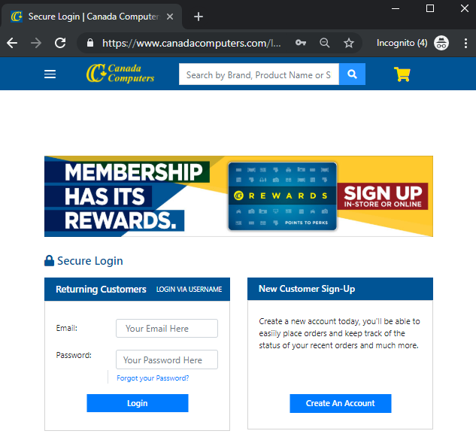

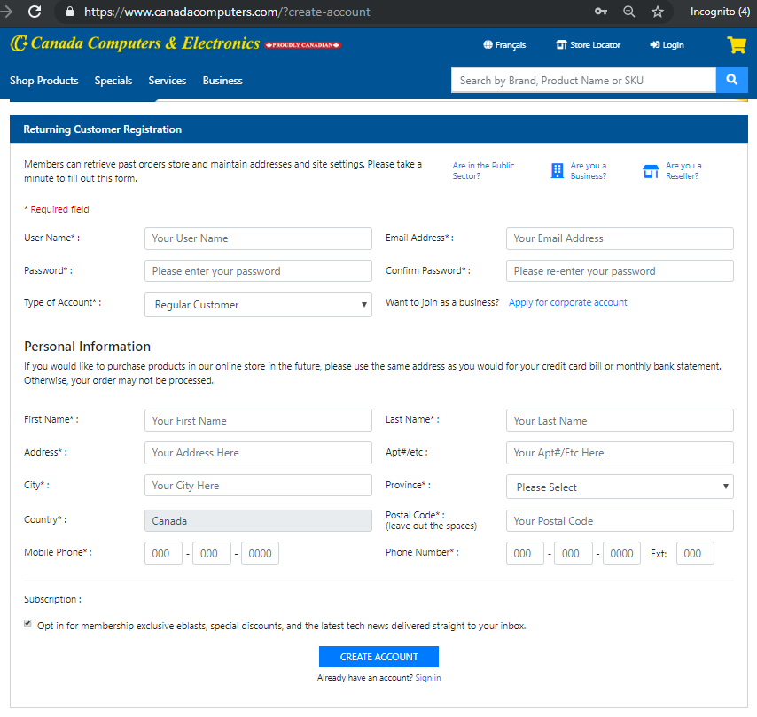

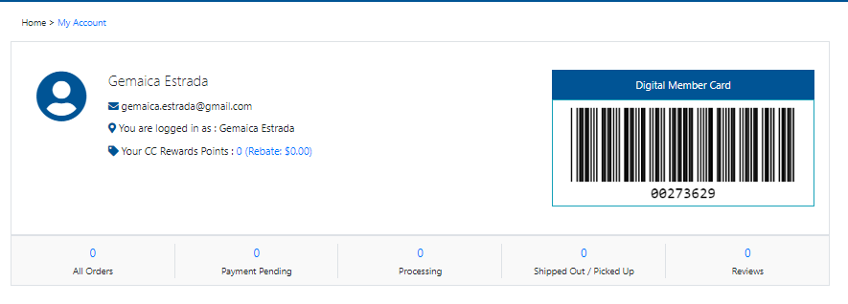

* + 1. Customer Table

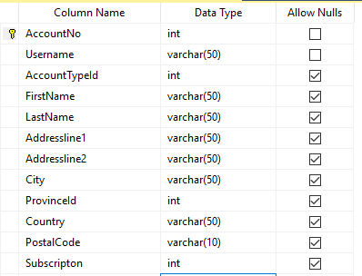

* + 1. Customer.Contact Table

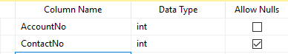

* + 1. Customer.Province Table

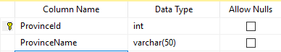

* + 1. Customer.Rewards Table

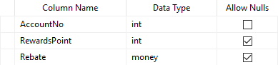

* + 1. Customer.Userlogin Table

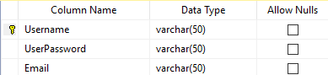

* + 1. AccountType Table

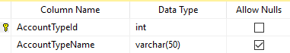

* 1. **Product Information**

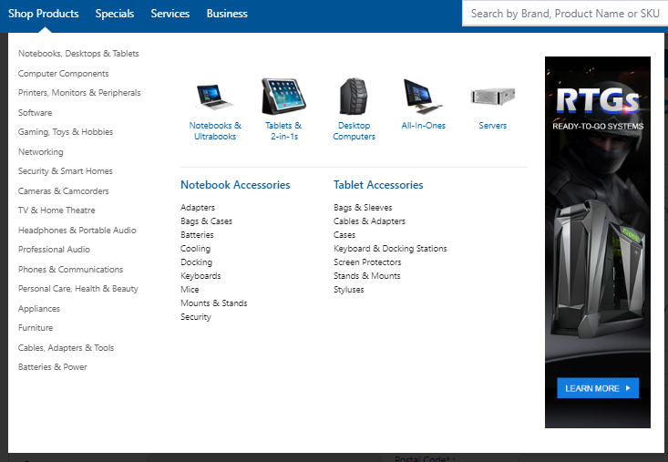

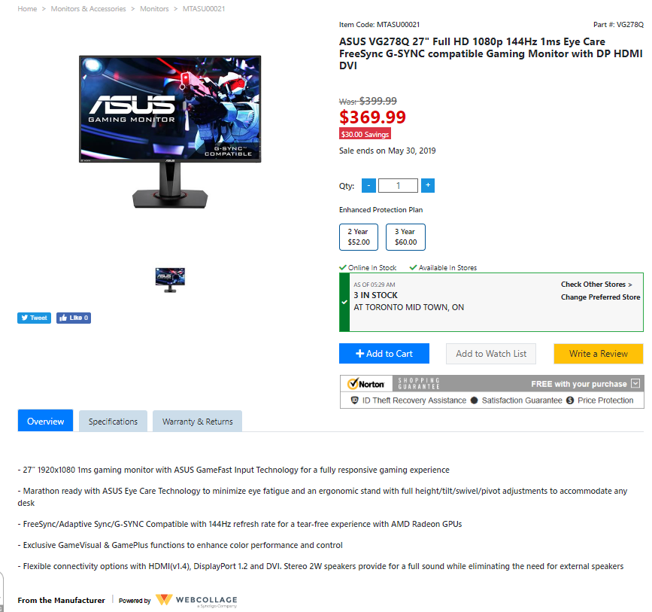

* + 1. Product Table

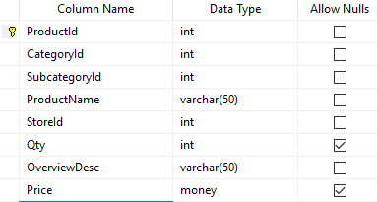

* + 1. Product.Category

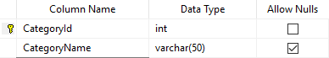

* + 1. Product.Image

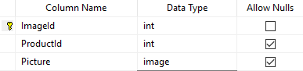

* + 1. Product.ReplacePlan

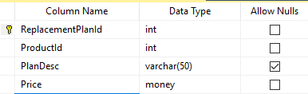

* + 1. Product.Review

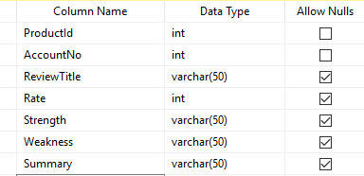

* + 1. Product.Specification

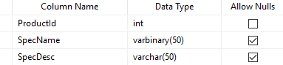

* + 1. Product.Subcategory

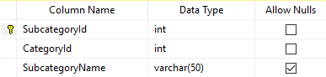

* + 1. Product.WarrantyandReturn

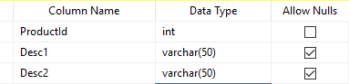

* 1. **Order Information/ Summary**

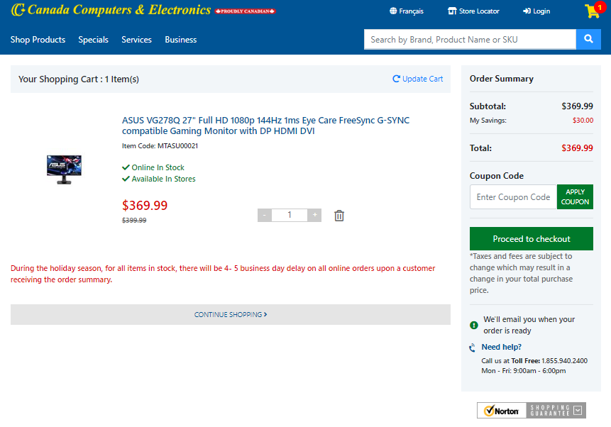

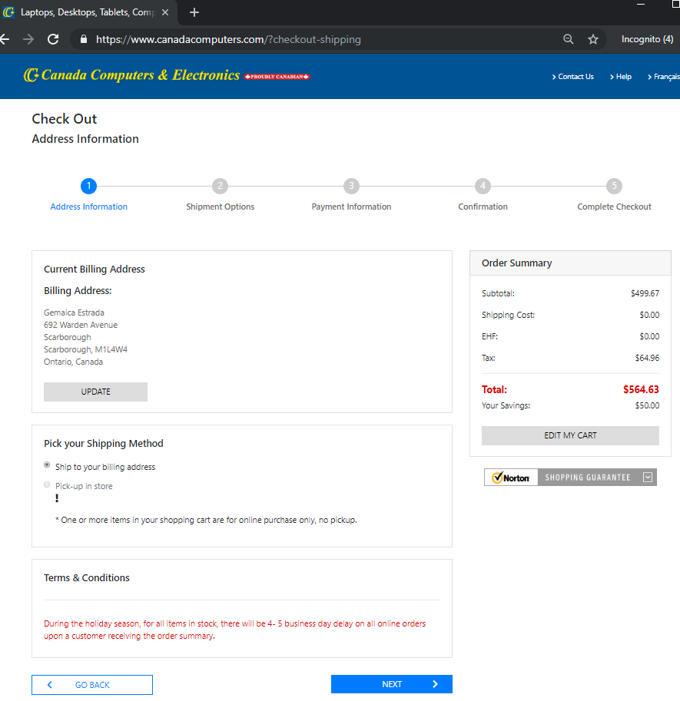

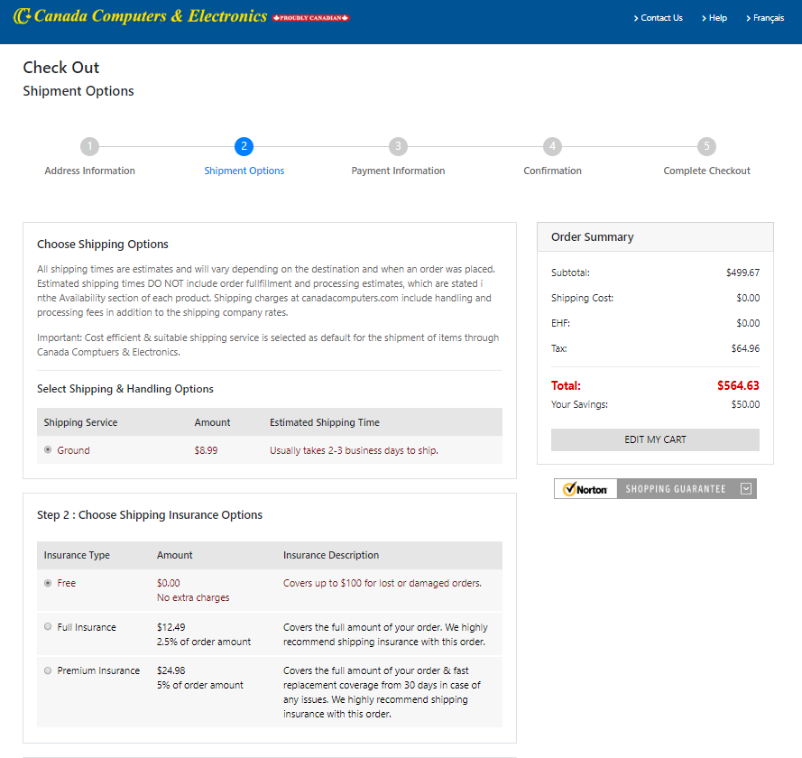

* + 1. Order

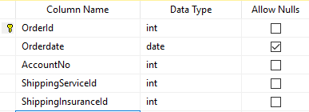

* + 1. OrderDetails

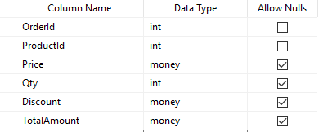

* + 1. ShippingInsurancePlan

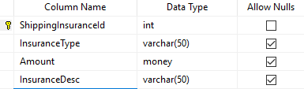

* + 1. ShippingService

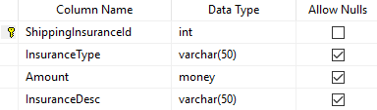

* + 1. Store

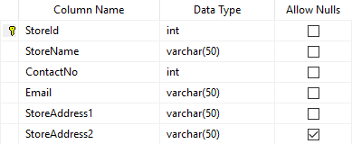

1. **ERD Design**

